Book

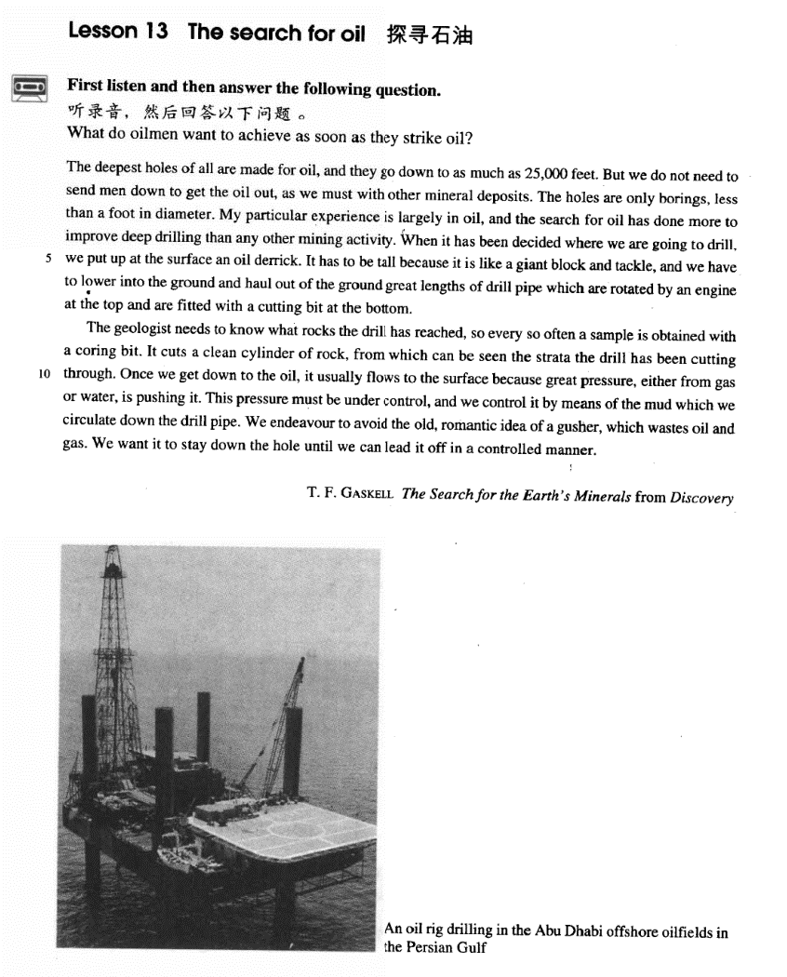

课文

The deepest holes of all are made for oil, and they go down to as much as 25,000 feet.

在所有洞穴中，为寻找石油所钻出的洞是最深的，这些洞可深达25,000英尺。

But we do not need to send man down to get the oil out, as we must with other mineral deposits.

但是，我们不必像开采其他矿藏那样，把人送到地下去把石油取出。

The holes are only borings, less than a foot in diameter.

这些洞只不过是一些钻孔，直径不到1英尺。

My particular experience is largely in oil, and the search for oil has done more to improve deep drilling than any other mining activity.

我是专门搞石油的，寻找石油比其他任何采矿业对改进钻探作的贡献都要大。

When it has been decided where we are going to drill, we put up at the surface an oil derrick.

当确定钻孔地点后，我们就在那里竖起一个井架。

It has to be tall because it is like a giant block and tackle and we have to lower into the ground and haul out of the ground great lengths of drill pipe which are rotated by an engine at the top and are fitted with a cutting bit at the bottom.

井架必须很高，因为它像一个巨型滑轮组。我们必须把很长的钻杆一节节地钻入地下，然后再从地下拉出来。钻杆顶部安装的发动机带动钻杆旋转，它的底部装有钻头。

The geologist needs to know what rocks the drill has reached, so every so often a sample is obtained with a coring bit.

地质学家需要知道钻头已以到达什么样的岩层，因此时常要用芯钻头取样。

It cuts a clean cylinder of rock, from which can be seen the strata the drill has been cutting through.

这种钻头能切割一段光滑的圆柱形岩石，从中能看出所钻透的地层。

Once we get down to the oil, it usually flows to the surface because great pressure either from gas or water, is pushing it.

一旦到达油层，石油就会由于地下巨大的压力流到地面上来，这种巨大的压力来自地下天然气或水。

This pressure must be under control, and we control it by means of the mud which we circulate down the drill pipe.

这种压力必须加以控制，我们让泥桨顺着钻杆向下循环，用这种方法来控制压力。

We endeavour to avoid the old, romantic idea of a gusher, which wastes oil and gas.

我们尽量避免使用陈旧天真的喷井方法，那样会浪费石油和天然气。

We want it to stay down the hole until we can lead it off in a controlled manner.

我们要让石油留在井下，直到我们能用一种有控制的方法把它引上来为止。

词汇讲解

### mineral

* **mineral** ['mɪnərəl] adj. 矿物质的；n. 矿物质
* **mineral** resources（矿产资源） / spring（矿泉） / water（矿泉水） / substance（矿物质） / deposits（矿藏）
* China is rich in **minerals**.
* metallic **minerals** 金属矿物质
* non-metallic **minerals** 非金属矿物质

**【扩展】**表达“矿”相关：

**ore** n. 矿；矿石

* iron **ore** 铁矿
* uranium **ore** 铀矿; 铀矿石

**mine** n. 矿，矿藏

* a coal-**mine**
* a gold-**mine**

### boring

* **boring** ['bɔ:rɪŋ] n. 钻孔；钻出的孔

**【同根词】**

**bore** v. 钻孔

* **bore** a hole in wood
* **bore** a tunnel through the mountain

**【近义词】**

**drill** v. 钻孔 n. 钻孔机；钻子

* **drill** for oil / water
* an electric **drill**

**【辨析】**

**perforate** v. 打孔；穿孔；打眼

* **Perforate** the cover to let air in.

**punch** v. 给 … 打孔；（用打孔器等）打孔

**prick** v. 扎；刺；戳

**pierce** v. 扎；刺破；穿透

* A small bead of blood formed where she had **pricked** her finger.
* She had her ears **pierced**.

### haul

* **haul** [hɔ:l] v. （持续而缓慢地）拖拉或提升
* Rescue workers attached the men to ropes before **hauling** them to safety.

**【近义词】【辨析】**

**drag** v. （使劲而吃力地）拖，拉，拽，扯

* He **dragged** the heavy chest across the floor.
* The police **dragged** the soccer hooligan off the pitch.

**tow** v.（用绳索或链条）拖，拉，牵引，拽；（车、船等的）牵引，拽引

* My car broke down and had to be **towed** to a garage.

**trail** v. （被）拖，拉; （尤指跟在他人后面）疲惫地走，没精打采地慢走，磨蹭

* She walked slowly along the path, her skirt **trailing** in the mud.

**tug** v. （常为几次用力）拉，拖，拽；（朝某一方向用力）拉，拖，拽

* We **tugged** it so hard that the rope broke.

**pull** / **draw** （没有场合限制）

### rotate

* **rotate** [rəʊ'teɪt] ['roʊteɪt] v. （使）（沿自身的轴）旋转
* **rotate** the handle gently

**【近义词】**表达“**（沿自身的轴）旋转**”：

**revolve**

* The restaurant **revolves** slowly, giving excellent views of the city.

**【辨析】revolve** 也可表示“公转” **（沿外部的轴）**

* The earth **rotates** on its axis while it **revolves** in its orbit.

**spin** v. （使）快速旋转

* The ice skater began to **spin** faster and faster.

**twirl** v.使轻快地转动；使旋转

* The couple was **twirling** to a waltz.

**circulate** vi. 传播，流传；循环；流通 ；vt. 使循环；使流通；使传播

* Blood **circulates** through the body.
* Open the window to allow the air to **circulate**.

**circulation** n. 流通，传播；循环；发行量

### geologist

* **geologist** [dʒi'ɒlədʒɪst] n. 地质学家

**【词根】【同根词】**

“**geo**” = earth

“**logy**”= to study

**geologist** n. 地质学家，地质学者

**geology** n. 地质学；地质情况

**geological** adj. 地质的，地质学的

**geologically** adv. 从地质学角度

* From the shore-line out to a distance which may be anywhere from a few miles to a few hundred miles runs the gentle slope of the continental shelf, **geologically** part of the continents.

**【辨析】**

“**geo**” + “**graphy**” = to write

**geographical** adj. 地理的；地理学的

**geographer** n. 地理学者

**geography** n. 地理；地形

**geographically** adv. 在地理上；地理学上

“**geo**” + “**metry**” = to measure

**geometry** n. 几何学

* solid **geometry** 立体何学

### strata

* **strata** ['strɑ:tə] ['streɪtə] n. 岩层；社会阶层
* people of different social **strata**

**注意单复数变化：**

stratum strata

datum data

medium media

bacterium bacteria

curriculum curricula

课文讲解

# （第一段）

# The deepest holes of all are made for oil, and they go down to as much as 25,000 feet.

知识点（1）

表达“凿一个洞”：

* **bore**/**drill** a hole **钻**
* **prick** a hole 扎
* **punch** a hole 冲
* **dig** a hole 挖
* **knock** a hole 撬
* **chop** a hole 凿
* **eat** a hole 咬
* **gnaw** a hole 啃
* **make** a hole （不强调方式）

知识点（2）

**go down** **to**往下走；（派生）南下；（派生）由重要的地方去次重要的地方

**go up to** 往上走；（派生）北上；（派生）由次重要的地方去重要的地方

* I’ll **go down to** Hangzhou tomorrow.
* I’ll **go up to** Dalian tomorrow.
* **go down to** the countryside
* **go up to** town

知识点（3）Lesson03-17、Lesson03-26、Lesson03-42 **长宽高重深**

**go down to as much as …** 深达

* The deepest holes of all are made for oil, and they **go down to as much as** 25,000 feet.

**extend to a depth of …** 深达

* The platforms **extend to a depth of** over 100 feet under the sea.
* The deepest known cave in the world is the Gouffre Berger near Grenoble. It **extends to a depth of** 3,723 feet.

**weigh …**系动词，有多重

* It **weighed** nearly 500 pounds.
* The boy **weighs** 50 kilos.

**be … (in weight)**有多重

* The boy **is** 50 kilos**(in weight).**

**be / stand … high / tall**有多高

* She **stood** （系统词）three feet high and her hands rested on her hips.
* He **stands** / **is** 1.8m **tall**.

**rise to a height of …**高达

* Above the surface of the water, the towers **rise to a height of** nearly 700 feet.

**be … deep / in depth** 有多深

* The hole **is** 2 feet **deep / in depth.**

**be … long / in length**有多长

* The bed **is** 2 meters**long / in length.**

**be … wide / across / in width**有多宽

* The river **is** 20 meters **wide / across / in width**.
* How do I love thee? Let me count the ways. I love thee **to the depth and breadth and height** my soul can reach. —— Elizabeth Barrett Browning

# But we do not need to send man down to get the oil out, as we must with other mineral deposits.

**语法分析：**

But we not need to send men down to get the oil out, as we must with other mineral deposits（as… 方式状语从句）.

知识点（1）

**send sb. to do sth.** 打发某人去做某事

**send sb. to sth.** 打发某人去某地

* **send** the boy **to** buy some beer
* **send** the boy **to** school / bed

**【近义词组】**

**dispatch sb. to do sth.** 打发某人去做某事

**dispatch sb. to sth.** 打发某人去某地

* The government **dispatched** 100 police **to** restore order.
* An ambulance **was** immediately **dispatched to** the area.

**transfer sb. to sth.** （工作调动）调动某人去某地

* He was **transferred to** our Shanghai branch.

**post sb. to sth.** 派遣某人去某地

* He was **posted to** the embassy in London.

**transport sb. to sth.** 流放某人去某地

* He was **transported to** Siberia for life.

知识点（2）

**语法：**as引导的方式状语中，主句出现的成分可省略

as we must with other mineral deposits.

…, as we must **send men down** with other mineral deposits.

# The holes are only borings, less than a foot in diameter.

知识点（1）Lesson04-13、Lesson04-29 **形容数量多少**

**【Part1】**

**语法：less than+数词+计量名词(时间；距离；金额)** 还不到…

* **less than** 20 minutes / a foot / 2 miles / 10 dollars
* The holes are only borings, **less than** a foot in diameter.

**语法：fewer than+数词+普通名词**

* There are **fewer than** 20 applications.
* The whole of Switzerland has **fewer than** six million inhabitants.

**【Part2】**

**语法：no less than+数词+计量名词(时间；距离；金额)** （强调数量特别大）“足足有……；有……之多”

**语法：not less than+数词+计量名词(时间；距离；金额)** “至少有……；不少于……”

* He won **no less than** $1,000,000 in the lottery.
* He won **not less than** $1,000,000 in the lottery.

**语法：no fewer than+ 数词 + 普通名词**“足足有……；有……之多”

**语法：not fewer than+数词+普通名词** “至少有……；不少于……”

* **No fewer than** a thousand people came.
* **Not fewer than** a thousand people came.

**注意**：当代英语：**less than**渐渐取代**fewer than**

**【Part3】**

**语法：no more than …** 只有、仅仅，只不过……

* **No more than** 20 people are present.
* When one seriously studies the social orders that have had the opportunity to develop autonomously, the figure becomes **no more than** an exact and matter-of-fact observation.

**语法：not more than …** 最多……

* **Not more than 2**0 people are present.
* She is **not more than** thirty.

知识点（2）

**diameter** n. 直径

**【词根】**

“**dia**”= across + “**meter**”/“**metry**”= measure

**radius** n. 半径

**caliber** / **calibre** n. 口径

# My particular experience is largely in oil, and the search for oil has done more to improve deep drilling than any other mining activity.

知识点（1）

**particular** adj. **specific**; **individual** 具体的、个人的

* in this **particular** case
* = in this **specific** case
* his **particular** problems
* = his **individual** problems

知识点（2）

**largely** adj. **chiefly** / **mainly** / **to a great extent**主要地、很大程度上

* His success was **largely** due to luck.

知识点（3）Lesson03-21

**do much / a lot / a great deal to …** 在…做出了很大贡献

**do little to …**没有什么贡献

**do nothing to …**完全没用

* Though he was technically a prizefighter, Mendoza **did much to** change crude prizefighting into a sport, for he brought science to the game.
* **造句：**尽管严格地说只是一本书，但圣经在把这个粗鄙的世界变成一个文明世界方面却做出了很大贡献，因为它给人类带来了信仰(faith)。
* Though it is technically a book, the Bible **does much to** change the crude world into a civilized one, for it brings faith to humanity.

**do more to … than …** 比后者作用更大

* **造句**：新概念英语比其他任何书对提高我写作能力的作用都大。
* New Concept English has **done more to** improve my writing skills than any other book.

# When it has been decided where we are going to drill, we put up at the surface an oil derrick.

**语法分析：**

When it（形式主语）has been decided where we are going to drill（真正主语）（when... 时间状语从句）, we put up *at the surface（地点状语前置）* an oil derrick（突出句末，连接下一句）.

知识点（1）

**put up**: **set up**; **erect** 致力起来

# It has to be tall because it is like a giant block and tackle and we have to lower into the ground and haul out of the ground great lengths of drill pipe which are rotated by an engine at the top and are fitted with a cutting bit at the bottom.

**语法分析：**

It has to be tall because it is like a giant block and tackle（结果状语从句）, and（大并列） we have to **lower** *into the ground（状语前置）* and **haul** *out of the ground（状语前置）* great lengths of drill pipe（**lower和haul宾语**） which are rotated by an engine at the top and are fitted with a cutting bit at the bottom（which...定语从句）.

知识点（1）

* 正常语序：头重脚轻

… we have to lower *great lengths of drill pipe which are rotated by an engine at the top and are fitted with a cutting bit at the bottom* into the ground and haul *them* out of the ground …

* It has to be tall because it is like a giant block and tackle, and we have to **lower** *into the ground* and **haul** *out of the ground* great lengths of drill pipe which are rotated by an engine at the top and are fitted with a cutting bit at the bottom.

知识点（2）【课文仿写】

* **造句**: 请把我们急需的那个软件从网站上下载下来然后通过e-mail 发送给我。
* Please **download** *from the website* and **send** *to me by email* the software of which we are in urgent need.

知识点（3）Lesson03-17、Lesson03-48 **量词**

* **a length** **of** rope / pipe / wire etc  **一根**…
* **a gust of** wind **一阵**风
* Oddly shaped forms that are suspended from the ceiling and move in response to **a gust of wind** are quite familiar to everybody.
* **a bar of**  chocolate **一块**巧克力
* **a bar / cake of** soap  **一块**肥皂
* **a slice of** butter**一片**黄油
* **a loaf of** bread **一块**面包 (长条)
* **a tube of** toothpaste **一管**牙膏
* **a cone of** ice-cream **一卷**冰淇淋
* **a bunch of**grapes / bananas **一串**
* **a flash / bolt of** lightning  **一道**闪电
* **a peal of**thunder **一声**雷
* **a pane of** glass **一块**玻璃
* **a bouquet of** flowers **一束**花
* a **fit** of coughing 一**阵**咳嗽
* a **round** of applause 一**阵**掌声
* **peals / gales** of laughter  **阵阵**笑声

知识点（4）Lesson03-03

**语法注意：名词前有量词，形容词放在量词前**

* a nice ***cup***of tea 一杯好茶
* a beautiful ***stretch***of field 一片美丽的田野
* a stagnant ***pool***of water 一潭死水
* For most of them, 50 pence is a small price to pay for a nice big ***bar***of chocolate.
* Our next obstacle was a shallow ***pool*** of water about half a mile across.

# （第二段）

# The geologist needs to know what rocks the drill has reached, so every so often a sample is obtained with a coring bit.

**语法分析：**

The geologist needs to know what rocks the drill has reached（what… 宾语从句）, so every so often（时间状语） a sample is obtained with a coring bit. （so… 结果状语从句）

知识点（1）Lesson03-44

表达“**时而，有时候**”：时间状语

**every so often**

**sometimes**

**occasionally**

**at times**

**(every) now and then**

**(every) now and again**

**once in a while**

**from time to time**

# It cuts a clean cylinder of rock, from which can be seen the strata the drill has been cutting through.

**语法分析：**

It cuts a clean cylinder of rock, f**rom which** can be seen **the strata（主语后置）** the drill has been cutting through（定语从句）. （**from which.**..非限定性定语从句）

**正常语序：**

… from which the strata the drill has been cutting through *can be seen*.

# Once we get down to the oil, it usually flows to the surface because great pressure either from gas or water, is pushing it.

**语法分析：**

Once we get down to the oil（时间状语从句）, it usually flows to the surface because great pressure, either from gas or water（插入语）, is pushing it. （because... 原因状语从句）

知识点（1）

**get down to** （字面含义）下降到…；（还表示）认真严肃的做某事

* Let’s **get down to** （认真严肃的做某事）business/ work / fundamentals / basics.

# This pressure must be under control, and we control it by means of the mud which we circulate down the drill pipe.

**语法分析：**

This pressure must be under control, and（大并列）we control it *by means of the mud which we circulate down the drill pipe**（which...定语从句，做circulate的宾语）*. （*by*... 方式状语）

知识点（1）Lesson03-33

**be under control** 在控制之中…

**get sth. under control** 控制住…

* **托福听力真题：**

A．The air will be cleaner if they go to a different city.

B．It’ll soon be too late to control the pollution.

C．Society will not pay attention to the new laws.

D．The situation will improve if changes are made.

* M: Look at all the pollution going into the air from those factories. Do you think they’ll ever **get that under control**?
* W: With the new laws and social awareness, we’ll turn things around.
* Q: What does the woman predict will happen?
* Answer: (D) The situation will improve if changes are made.

**get out of control / hand** 失控

* A day may begin well enough, but suddenly everything seems to **get out of control**.
* **托福听力真题：**

A．Discuss the situation with the person in charge of the dormitory.

B．Ask her roommate not to make so much noise.

C．Go to bed after midnight.

D．Send a letter to the residents.

* W: You know the noise in my dorm has really **gotten out of control**. My roommate and I can rarely get to sleep before midnight.
* M: Why don’t you take the problem up with the dorm supervisor?
* Q: What does the man suggest the woman do?
* Answer: (A) Discuss the situation with the person in charge of the dormitory.
* **6级选择题：**
* We started burning some leaves in our yard, but the fire got*­­* ___A___and we had to call the fire department to put it out.

A．out of hand 失控

B．out of order 出故障

C．out of the question 不可能

D．out of the way 闪开

知识点（2）Lesson04-13**介词under表示“在…状态之中”**

* The car is **under repair**. 在修理之中
* The castle is **under** **attack**. 遭受仅供
* The subject is **under** **discussion**. 讨论之中
* The matter is **under** **consideration**. 考虑之中
* You are **under** **arrest**. 被捕了
* The patient is **under** **observation**. 观察之中
* The case is **under** **investigation**. 在调查之中
* The bridge is **under** **construction**. 建造之中
* The building is **under** **renovation**. 整修之中

# We endeavour to avoid the old, romantic idea of a gusher, which wastes oil and gas.

**语法分析：**

We endeavour to avoid the old, **romantic（不切实际的）** idea of a gusher, which wastes oil and gas（which...定语从句，充当原因状语）.

知识点（1）Lesson04-06

**【近义词组】**表达“**竭尽全力做某事**”：

**endeavor / endeavour to do**

**make every endeavor to do**

* We **endeavour to** avoid the old, romantic idea of a gusher, which wastes oil and gas.

**do / try one’s utmost to do** 竭尽全力做某事

= **do / try one’s best to do**

* Though the doctor **did his best**, the patient's recovery was slow.
* You play to win, and the game has little meaning unless you **do your utmost to** win.

**go to great lengths to do** Lesson03-28

* The man **went to great lengths to** prove that the diamonds were real.

**spare no effort to do** 不遗余力的 Lesson04-02

* I will **spare no effort to** learn English.

**give one’s all to do**

**go all out to do**

* **托福听力真题：**

A. They should wait for John to bring the dessert.

B. He thinks John must have spent a lot of money for the dinner.

C. The dessert also looks impressive.

D. He helped John make the sandwiches.

* W: Look at the delicious sandwiches. John’s really **gone all out** this time.
* M: Just wait until you see the dessert.
* Q: What does the man imply?
* Answer: (C) The dessert also looks impressive.

知识点（2）

**romantic** adj. **impractical** 不切实际的

知识点（3）

定语从句充当**原因**状语

* We can read of things that happened 5,000 years ago in the Near East, *where people first learn to write*.
* We can read of things that happened 5,000 years ago in the Near East, *because*people first learned to write *there*.

* We endeavour to avoid the old, romantic idea of a gusher, *which*wastes oil and gas.
* We endeavour to avoid the old, romantic idea of a gusher, *because it*wastes oil and gas.

# We want it to stay down the hole until we can lead it off in a controlled manner.

**语法分析：**

We want it to stay down the hole until we can lead it off（副词） *in a controlled manner**（方式状语）* （until… 时间状语从句）.